Congratulations!
You have earned the Super Kid reward!
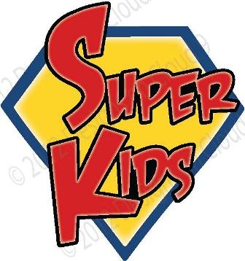
Awarded to: _____________
Mr. Cawson’s Class 2018-19

