Narrative Elements
Save Me a Seat by Sarah Weeks
The first chapter of Save Me a Seat is called Ravi. It is taking place in America at Albert Einstein Elementary School in room 506. This school is in Hamilton, New Jersey. This chapter primarily took place in the morning because it was the start of a school day for Ravi. In the chapter, the weather was mostly sunny. The main character moved to America from Bangalore, India where he attended “Temple of Knowledge.” He is currently in a 5th grade class with Mrs. Beam.

Problem and Solution
Save Me a Seat by Sarah Weeks
The problem in the chapter titled Ravi is that the move to America has been very difficult for the family. His grandma clearly does not like America because she mentions how Ravi does not want to be like them. The family was used to having whatever they wanted and now they have to adjust to a smaller house with not getting everything they want. The housing situation has been uncomfortable to say the least. In the class, Ravi struggles with English which causes communication issues. His teacher told him he needed to work on his English, but Ravi thought his English was fine. At his old school he was considered a star student and he felt that his peers would have laughed at him for being treated like an idiot.
A possible solution to this problem could be starting a friendship with ABCD Dillon. This friendship could help Ravi make more friends and become more popular.

Events
Save Me a Seat by Sarah Weeks
In the first chapter, the story was told through Ravi’s point of view. In the second chapter, the story was told through Joe’s point of view, who had two friends who moved away. Now, he does not have any friends left causing him some concerns for the school year ahead. Also, Joe eats a lot and is always hungry making lunch time his favorite subject. Last year, Joe sat behind Dillon, the popular and supposedly smart bully who wears fancy boxers, but now Ravi sits behind him. When Joe walked into his class, Dillon was standing by the girls and would not stick out his tongue. Tom, a Dillon wannabe, stuck out his tongue to try and get Dillon to do it, too. Finally, Joe was hoping that Dillon would pick on Ravi this year because he does not want Dillon to pick on him again.
Connections
Save Me a Seat by Sarah Weeks
In the story “Save Me a Seat”, Ravi doesn’t speak the same language as they do at Albert Einstein Elementary. This makes it hard for him to make friends and for people to understand him. For example, when he was doing the project with Emily, he was trying to complete the task, but the language issues did not allow them to finish. In a connection to this, I went to a new school outside of Michigan. At this school, they spoke a different language that I did not know how to speak. This made it very hard to make friends or to get anything such as using the bathroom, making a lunch choice, or asking for help.

Questions
Save Me a Seat by Sarah Weeks
In Save Me a Seat by Sarah Weeks, I would ask the following questions.
- How do you think your life choices changed who you are today?
  - I think Ravi would say, “Working with people in another country, I have noticed a lot of people do not treat me with respect. This is making me feel a lot more negative lately and perhaps becoming a bitterer person. In addition, I chose to work hard in school because in India we believe in trying our hardest in our education. This is making me a more knowledgeable human being.”
- At lunch time, what do you think Dillon was laughing about?
  - I think Joe would say, “I think Dillon was laughing about myself or the skinny new kid with the mile long name because he has picked on me for a very long time.”
- Why did you start bullying Joe in the first place?
  - I think Dillon would say, “Joe eats a lot and he is incredibly tall and large. His last name is also a character from the Looney Toons.”
- Why doesn’t your grandmother like the Americans?
  - I think Ravi would say, “My family always had issues with the Americans. They have always picked on our culture and traditions.”
- Why are you always sagging your pants?
  - “I really like attention and want people to look at me more. I also like being popular and so far it’s working out very well for me wearing themed underwear.”

Compare and Contrast
Save Me a Seat by Sarah Weeks
In the book Save Me a Seat, there are some similarities and differences between Joe and Dillon. One similarity is that they both are boys who attend Albert Einstein Elementary. Both of them are insecure being that one is a bully while the other wants popularity to feel good. In the text, Dillon says things like “hey Pud!” while Joe tries to hide from him. With Joe, he lacks friends while on the other hand, Dillon has many friends. We know this because it said that Joe sits by himself while Dillon is surrounded by his friends. Additionally, Dillon is aggressive while Joe is clearly not. Another difference is that Joe gets teased and Dillon does not (he picks on Joe). This is shown when Dillon ran over to Joe and wrapped himself around him to tease him about his mom working at the school. Stemming from that, Dillon is quite the show off with his popularity whereas Joe is incredibly shy.

Character Traits
Save Me a Seat by Sarah Weeks
I am reading Save Me a Seat and I chose Ravi. One of the traits I chose for Ravi is judgmental. One of the reasons I chose this trait is because in math he saw Joe not wearing formal clothing and thought he was a little sloppy for school. Another reason is because right when he saw Dillon, he thought he was an ABCD based on his looks and the way he acted. Another character trait is that Ravi is quite the show off. In the text it said Ravi thought it was okay to show off at school and he did this by making math look easy. Also in the text, he had all of his supplies ready and neat on his desk for everyone in class to see. I conclude that Ravi is a judgmental show off based on the textual evidence.

Visualizing
Save Me a Seat by Sarah Weeks
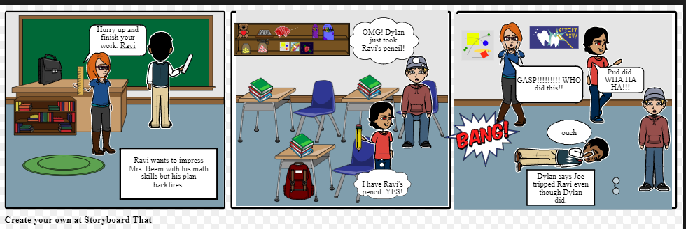 In the story Save Me a Seat, Ravi was used to being the smart, intelligent student back in his home country of India. At Albert Einstein, he is being told he needs academic support. This is incredibly frustrating to him. One night, his family talks to him about showing off his talents. The next day at school, he could not wait to exhibit his mathematic skills. His teacher, Mrs. Beam, presented a problem on the board. She gave students a chance to volunteer to solve it in front of the class. Ravi could not wait to be chosen. Then, Mrs. Beam chose Ravi. He was so excited that he flung up from his seat, knocked his things off of his desk, and when Joe went to help him, they bumped heads. After that, Joe accidentally steps on Ravi’s name tag. His plan to impress her had completely backfired. After he solved the problem, Dillon trips Ravi when he was on his way back to his seat. Yet, to Ravi’s perspective, Dillon blames Joe and Ravi believes him. As Dillon tripped Ravi, he also managed to demonstrate his thieving skills and takes some of his mechanical pencils he had been eyeballing the whole time. Mrs. Beam was left confused, wondering if she should inform the school nurse. At the end of it all, Ravi was very angry with Joe, believing it was “Big Foot” who tripped him. He still has yet been able to demonstrate his intelligence at Albert Einstein leaving him incredibly frustrated.

Context Clues
Save Me a Seat by Sarah Weeks
Assimilate – cause to resemble (blend in)
Acquaintance – someone who knows someone slightly; not a close friend.
Tiffin Box – type of lunch box from South Asia made to carry Tiffin lunches.
In the story Save Me a Seat by Sarah Weeks, I noticed 3 words that I found unusual. One of them was assimilate. Assimilate means to cause to resemble, or to blend in. In the text, Ravi and his class found it in a social studies textbook talking about Native Americans blending in to the white society. Another word that I found was acquaintance. This means someone who knows someone slightly, but they are not a close friend. In the text, Ravi mentioned that Miss Frost and Joe were both acquaintances to him. Lastly, the word Tiffin Box was used. This was a type of lunch box from South Asia used to pack Tiffin lunches. In the text, Ravi mentioned having a Tiffin lunch inside his Tiffin Box. I found all three definitions of these words that were in Save Me a Seat using Google Dictionary.

